Experiment-6
Familiarization and Usage of Cloud Services Using AWS and Open-Source Cloud Tools
Task 1: VM Setup
Step 1: Create a Virtual Machine
Step 2: Install Ubuntu
Step 3: Update Ubuntu
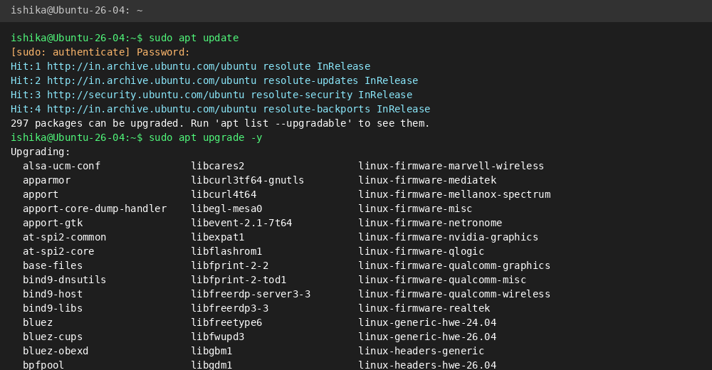
Step 4: Install Basic Utilities
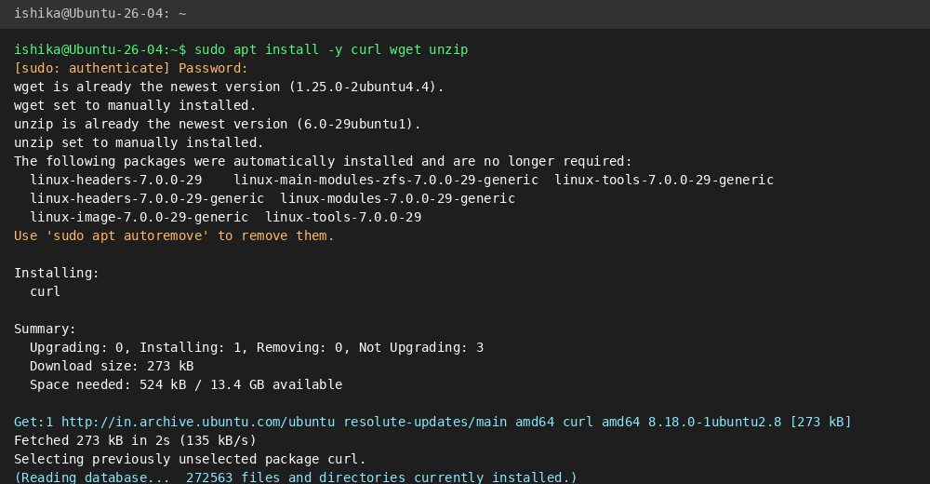
Task 2A: Introduction to AWS Management Console
Step 1: Access AWS Management Console
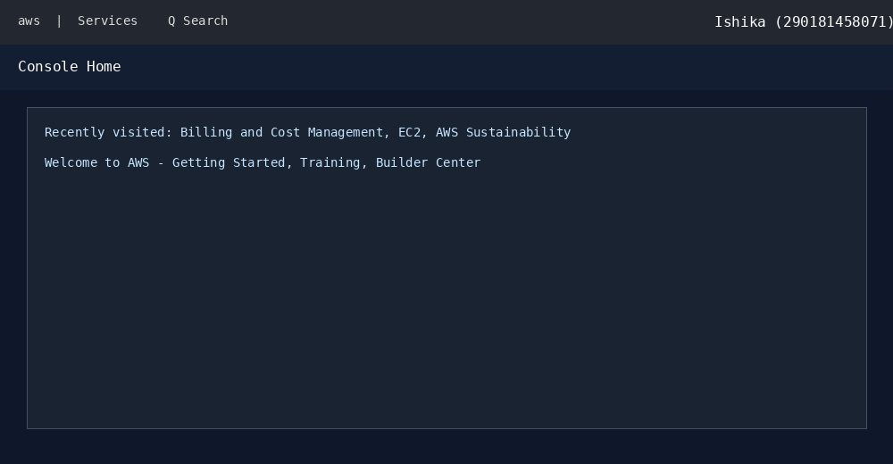
Task 2B: Implementation of Cloud Storage Using Amazon S3
Step 1: Open Amazon S3
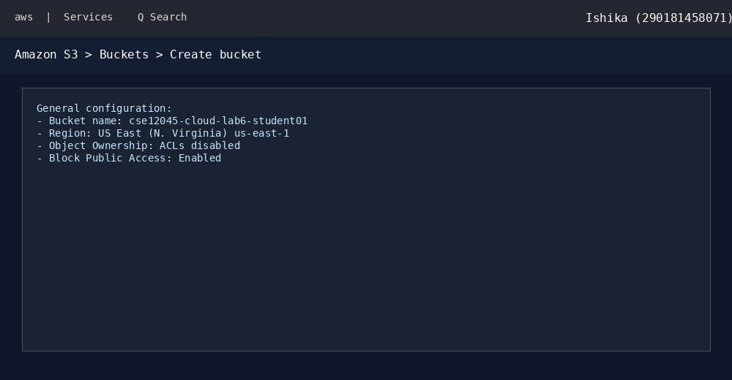
Step 2: Create an S3 Bucket
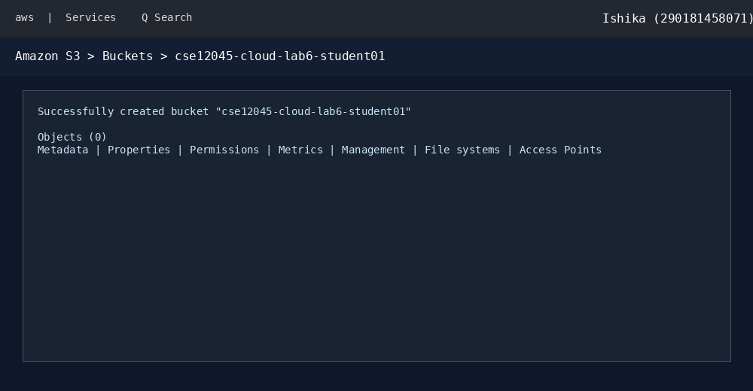
Step 3: Create a Sample File in Ubuntu
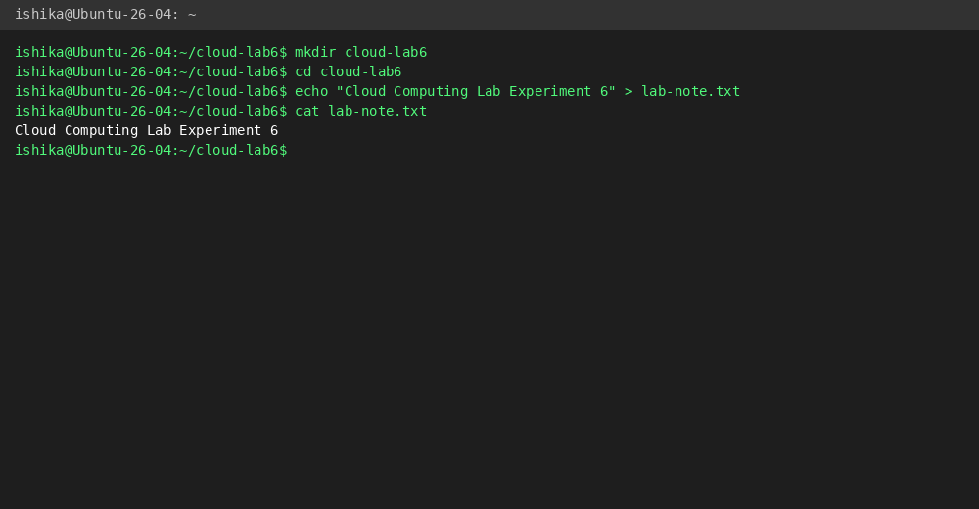
Step 4: Upload a File to S3
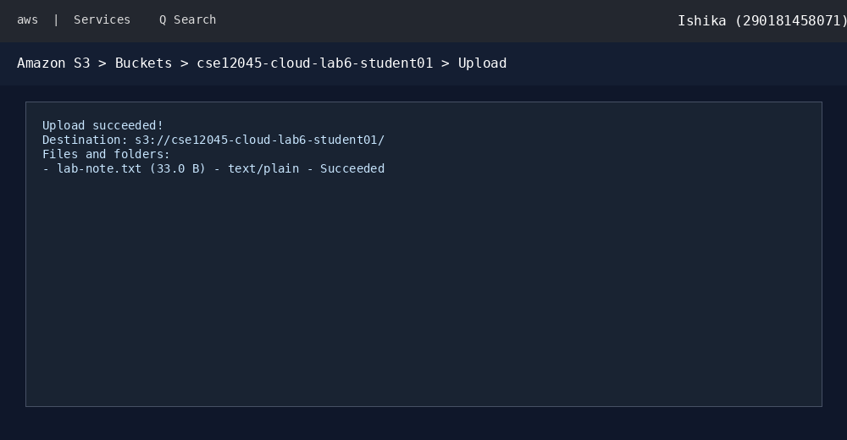
Step 5: Download the File
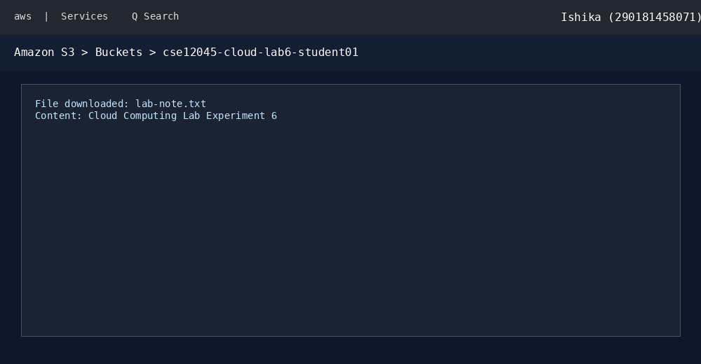
Task 3A: Identity and Access Management Using AWS IAM
Step 1: Open IAM
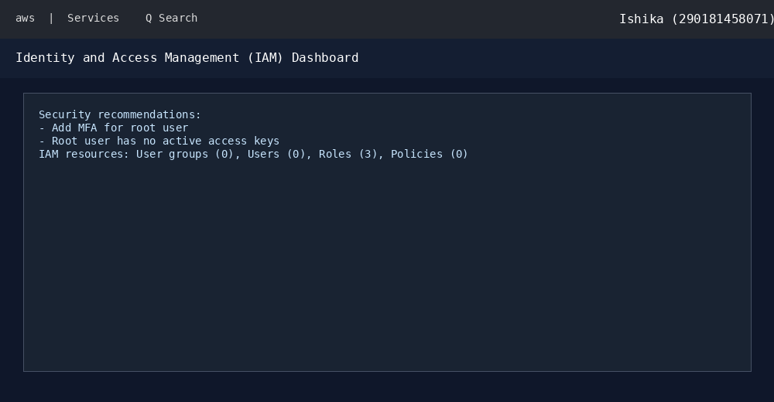
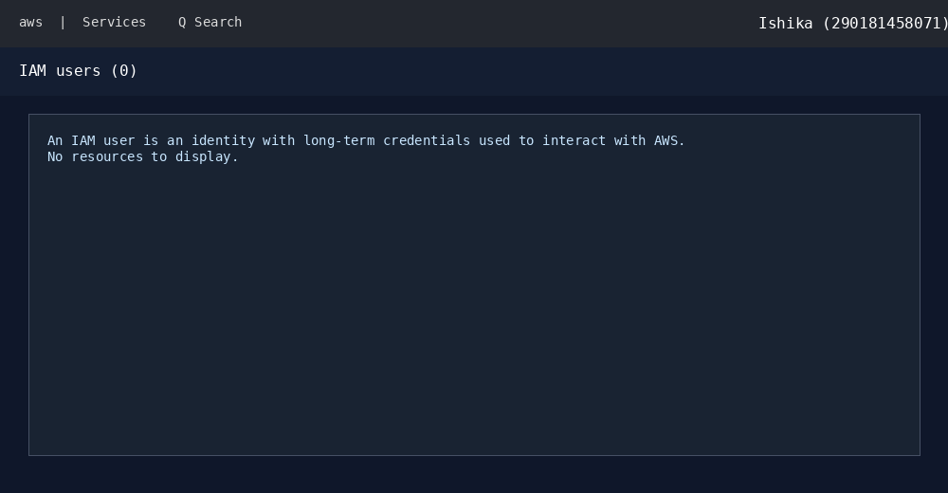
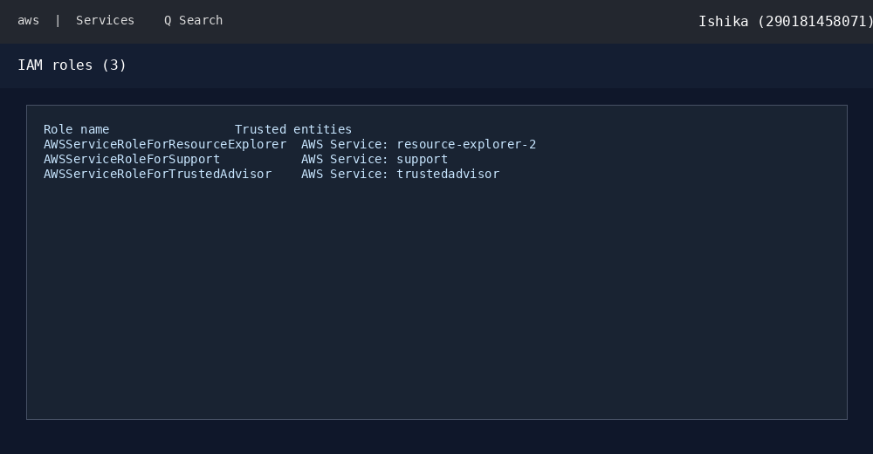
Task 3B: Virtual Machine Provisioning Using Amazon EC2
Step 1: Open EC2
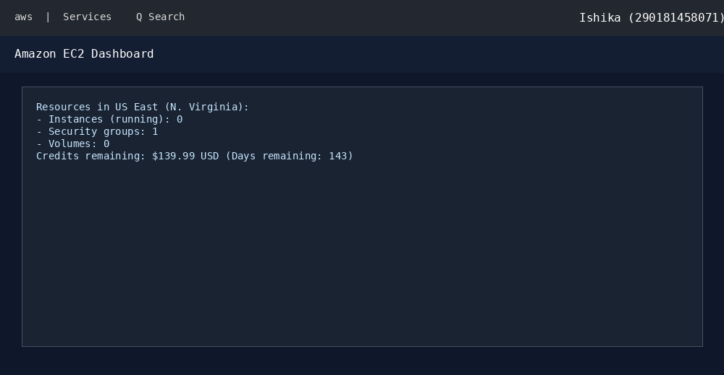
Step 2: Explore the Instance Launch Process
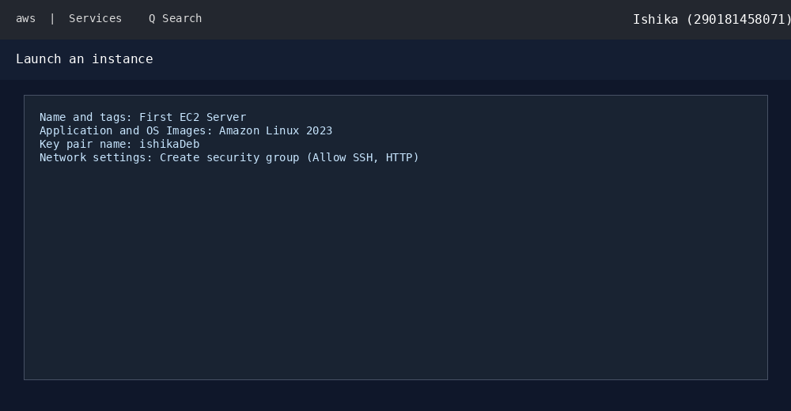
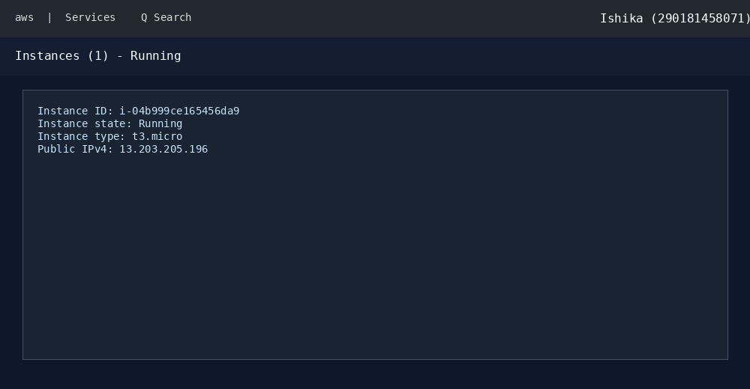
Task 4A: Virtual Networking Using Amazon VPC
Step 1: Open Amazon VPC
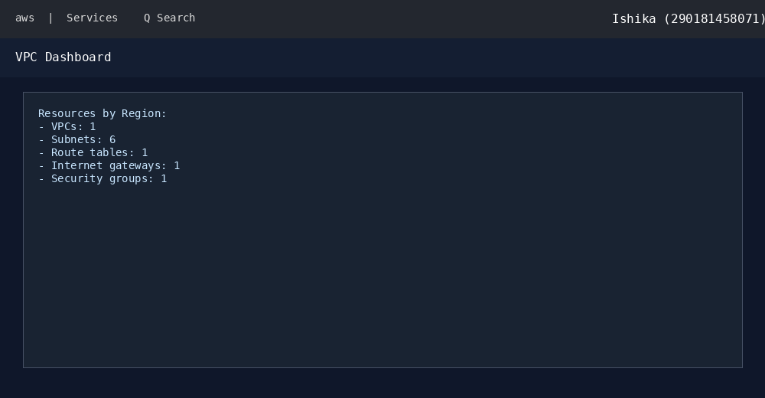
Task 3D: Cloud Monitoring Using Amazon CloudWatch
Step 1: Open CloudWatch
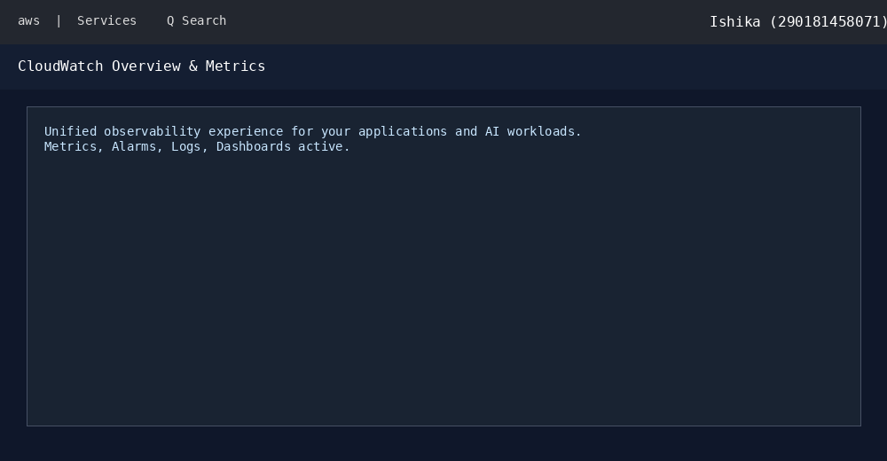
Task 4B: Basic AWS Operations Using AWS CLI
Step 1: Open AWS CloudShell & Install AWS CLI


